On December 29, 2018, SNM Tracy branch, California, USA got an opportunity to assist the people who were affected by the deadly California wildfires. Nine sewadal members from SNM Tracy branch reached Chico, California at the warehouse of The Salvation Army of USA. Our sewadal members were given the sewa to assist people with find the items they need at this difficult time in their lives. The warehouse provided clothes, shoes, bathroom supplies, first aid supplies, food, etc. and many other daily use items. Sewadal members were able to help about 27 families.
On November 8th, 2018 the fire started near the city of Paradise, California and by the time the fire was contained, 79 people had lost their lives and thousands of people had lost their houses and everything thing they owned.
Sewdal members were able to help 27 families. This event also gave our us an opportunity to serve our community at large and also to introduce San Nirankari Mission to the general public.
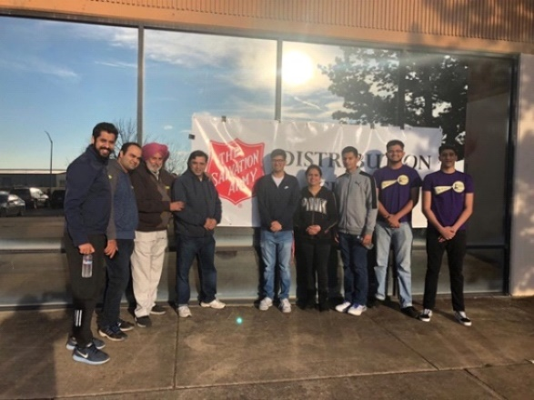
From left to right: Vivek Madan, Kunal Khanna, Ajit S Sooch Ji, Samar Narang, Jashan Binder, Aradhana Sooch, Shlok Sooch, Aashrit Sharma and Rajan Binder

